Reverse Dictionary

What is Reverse Dictionary
# Source: AI Source: Provided by: [Data Path: Persons Table -> ID Column: 1, Name_En Column: Motasem Essam] -> From: [Chatgpt (GPT-4-turbo)] on [7/29/2025]
A Reverse Dictionary is a unique reference tool that allows users to find a word based on its definition, concept, or description, rather than looking up the meaning of a known word. It's especially useful when you know what you want to say, but not the exact word for it.

🔹 Key Features of a Reverse Dictionary
# Source: AI Source: Provided by: [Data Path: Persons Table -> ID Column: 1, Name_En Column: Motasem Essam] -> From: [Chatgpt (GPT-4-turbo)] on [7/29/2025]
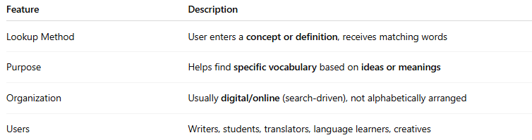
Feature | Description
Lookup Method | User enters a concept or definition, receives matching words
Purpose | Helps find specific vocabulary based on ideas or meanings
Organization | Usually digital/online (search-driven), not alphabetically arranged
Users | Writers, students, translators, language learners, creatives

🔹 Examples of Reverse Dictionaries
# Source: AI Source: Provided by: [Data Path: Persons Table -> ID Column: 1, Name_En Column: Motasem Essam] -> From: [Chatgpt (GPT-4-turbo)] on [7/29/2025]
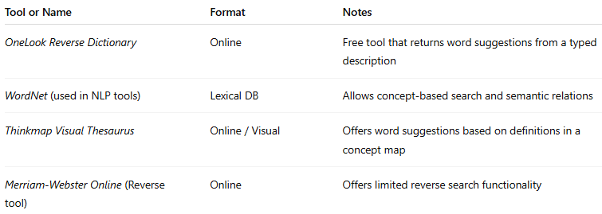
Tool or Name | Format | Notes
OneLook Reverse Dictionary | Online | Free tool that returns word suggestions from a typed description
WordNet (used in NLP tools) | Lexical DB | Allows concept-based search and semantic relations
Thinkmap Visual Thesaurus | Online / Visual | Offers word suggestions based on definitions in a concept map
Merriam-Webster Online (Reverse tool) | Online | Offers limited reverse search functionality

🔹 Advantages
# Source: AI Source: Provided by: [Data Path: Persons Table -> ID Column: 1, Name_En Column: Motasem Essam] -> From: [Chatgpt (GPT-4-turbo)] on [7/29/2025]
- Aids in vocabulary retrieval and avoiding “tip-of-the-tongue” moments
- Useful for writing, brainstorming, and creative word use
- Enhances precision and variety in language use
- Supports semantic search in computational linguistics

🔹 Use Cases
# Source: AI Source: Provided by: [Data Path: Persons Table -> ID Column: 1, Name_En Column: Motasem Essam] -> From: [Chatgpt (GPT-4-turbo)] on [7/29/2025]
- Writers searching for the perfect word
- Students improving lexical range
- Linguists and NLP researchers modeling semantic relationships
- Translators matching concepts to target language terms

